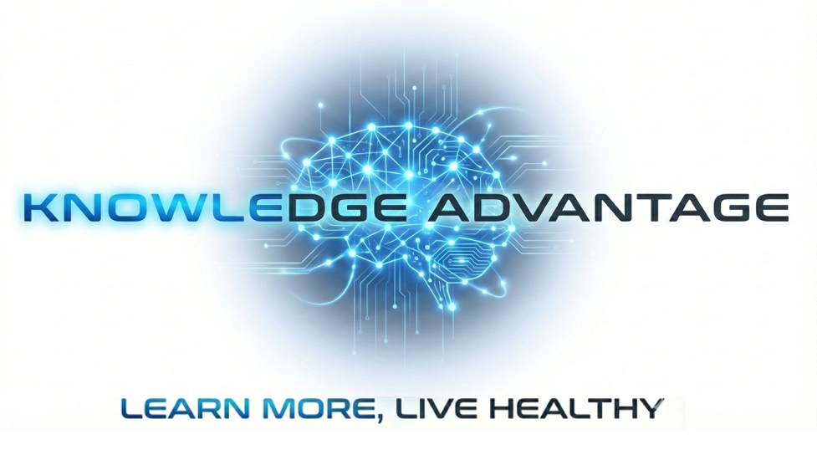

Our Mission:
Improve Patient Education by shifting the focus from ‘educating; telling people ‘what to learn’ to teaching people ‘how to learn’.

Background
Studies show patients receiving comprehensive education have shorter hospital stays, better pain management, and higher satisfaction than those without education Engagedmd. One recent study found patient revisit rates dropped from 53% to 41% after implementing educational intervention PubMed Central. Low health literacy costs the U.S. healthcare system substantially, with health costs four times higher for those with low health literacy.
The Problem with Patient Education:
- Adoption is low - Less than 50% of patients register to use patient portals, and routine usage is even lower Oxford Academic, despite these being key educational delivery channels.
- Implementation barriers - Healthcare providers face time constraints during consultations that hamper their ability to offer in-depth, personalized education PubMed Central. Nurses cite lack of resources, inadequate time, insufficient knowledge and skills, and lack of patient readiness as major barriers ResearchGate.
- Equity gaps - Approximately 93 million American adults have low health literacy, with only 12% considered proficient Globo. Some patients are "hardly reached" by education programs due to lower educational levels, severe co-morbidity, low health literacy, and sociocultural problems NCBI.
- Inconsistent quality - Most patient education materials aren't written for the average American reading level of 7th-8th grade MicroMD

The Bottom Line

Patient education should work and can work when properly implemented. But there's a large gap between the controlled studies showing benefits and real-world implementation where time pressures, literacy mismatches, limited adoption, and resource constraints undermine effectiveness. The promise is there, but many healthcare systems haven't yet figured out how to deliver it reliably at scale.
Too often, patients, caregivers and family members resort to Google for medical care advice. Misinformation compounds the problem of being poorly informed when faced with heath challenges. In the extreme, confusion leads to desperation and then anger as patients feel abandoned and malpractice accusations rise.
The problem
We are ‘educating’ people, tell people what they need to know not encouraging them to learn how to learn, the Critical Thinking skills needed to learn. Educational programs are developed to be efficient. Learning is a personal commitment to learning how to learn..
Knowledge Advantage is a Critical-Learning Hub where patients, caregivers and families can learn. It’s also a hub for experts to collaborate. We are starting with developing a comprehensive intelligent ‘book’. We used AI to exhaustively research a subject: dementia. With assistance from AI we identified 200 topics discussed in biomedical literature , topics linked to dementia. These 200 topics were then arranged in a Learning Graph so one can literally See the Corpus of Knowledge:
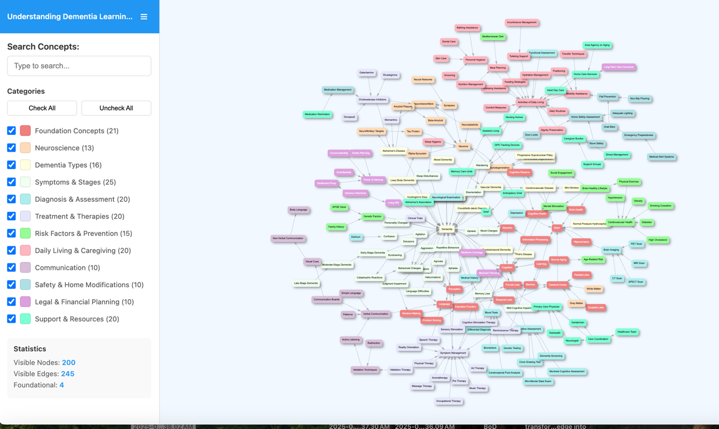
This Interactive Learning Graph, is a key step in developing our ‘Book’

Intelligent Book Generation Workflow
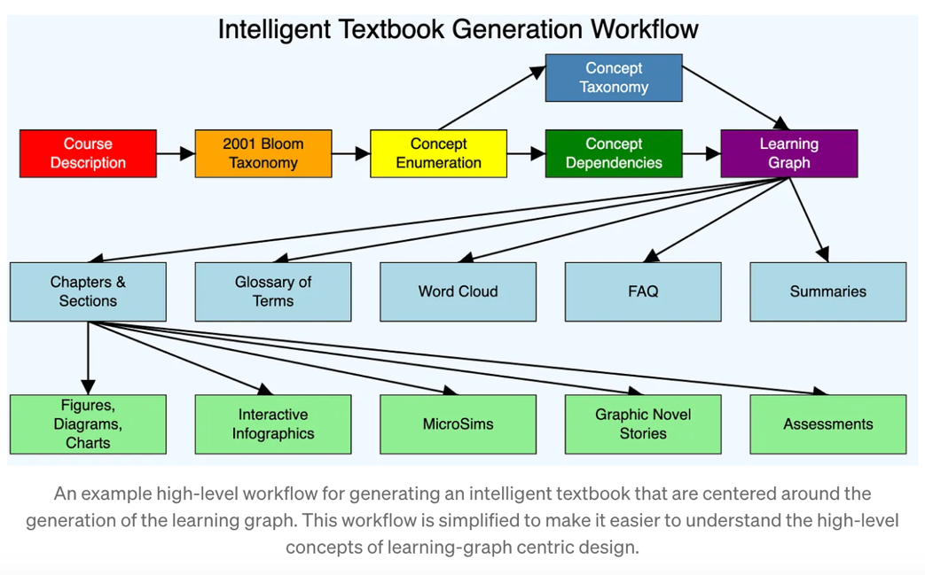
Our goal is to supplement learning by providing an Intelligent ‘book’ for patients, caregivers and family members and follow this with podcasts.
We are within weeks of releasing the ‘first edition’ of our online Dementia Reference Book.
Our goal is to demonstrate the effectiveness of levergaging AI to write a book. And use this to engage those willing to collaborate to advance the development of the material. This is what we envision as a Citical Learning Hub.
We share a methodology and technologies that are being used to develop and distribute intelligent text books for schools in Africa. Nearly 100 of these books have been released so far. Students in Africa are learning advanced subjects like linear algebra and applied physics using intelligent textbooks maintained by a small team located here in Minneapolis. We are confident that we can provide personal learning at scale.
About us
Knowledge Advantage is a continuation of Information Advantage, Inc., a pioneer in supporting advanced quantitative data analysis. AI is advancing qualitative data analysis.
Knowledge Advantage’s roots were planted 10 years ago. when we developed technology for by a grant-funded project, Care-to-Plan; a project lead by the University of Minnesota, School of Nursing.
https://pmc.ncbi.nlm.nih.gov/articles/PMC5181391/
Care-to Plan-was “an online resource directory for dementia caregivers (e.g., relatives or unpaid nonrelatives) that generates tailored support recommendations.” It was well received and positively reviewed by over 400 experts.
The development of this online resource recommendation engine was undertaken 10 years ago, prior to having the powerful AI tools needed to ‘move mountains of information’. Care-to-Plan underscored the importance of learning about this disease; however ,the monumental task of developing a comprehensive resource directory turned out to be an insurmountable barrier. Today, with AI, we have a comprehensive database, a Large Language Model, that includes biomedical literature and a directory of community-based resources
From the Learning Graph, AI organized the topics into 15 chapters and the created an outline for each chapter in a few minutes.
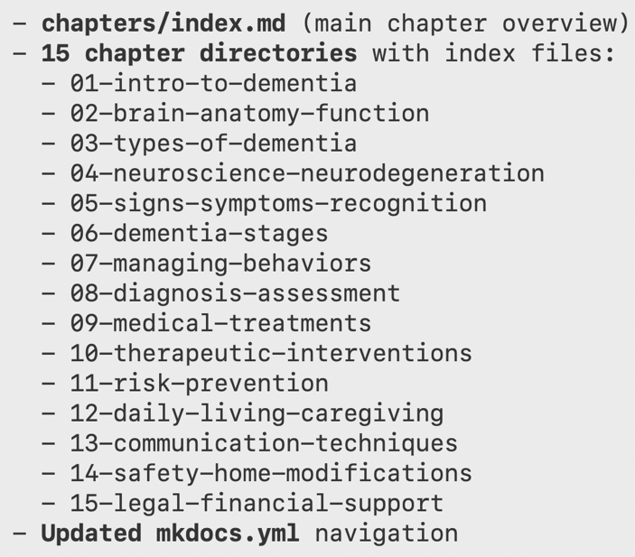
As of today, the first 6 Chapters are at the first draft level.
